Title of Session: The Origin and Early Development of the Internet and of the Netizen: their Impact on Science and Society.

Organizer: Ronda Hauben (USA)

This session focused on the history of the development of computer networks, the linking of these networks via the creation of the Internet, and the emergence of the active participants in these networks, the netizens (i.e., net.citizens). Our session included papers about the scientific development of networking technology, and about the impact of the Internet.

The Internet will continue to develop and impact society, but already the Internet has a history, the as yet untold history of its development as a science and a technology. Also, emerging with the Internet has been the netizen. The talks presented in our session considered the historical organizations and threads which brought forth the Internet and the netizen. They also explored the vision that gave birth to the networking developments of our time and the continuing relevance of this vision.

The Internet has made it possible to link diverse networks around the world, and the citizens of these networks, into a global public sphere populated by citizens of the world, by netizens. This development is a product of scientific/technical research, of research in resource sharing and in interactive communication on both technical and social levels. It is also a product of the activity of the users and of the netizens. The emergence of netizens is one of the spectacular achievements of the creation and development of the Internet, an achievement that as yet has received little attention. The netizens movements in countries like Korea and China are an important component of the international development of netizens. Our session explored both the development of the technology and of the online participants in these important technical developments.
-------------

The International and Scientific Origins of the Internet and the
Emergence of the Netizen

Ronda Hauben, rh120@columbia.edu
Columbia University, New York, USA

ABSTRACT

The mythology surrounding the origins of the Internet is that it began in 1969 in the US. That is the date marking the origin of the ARPANET, a US packet switching network, but not the birth of the Internet. The origin of the Internet dates from 1973. The actual goal of the researchers creating the Internet was a technical and a scientific goal. It was to create a network of networks, a means for networks from diverse countries to intercommunicate. At the time, there were several national, but diverse networks being planned or in development. These included NPL in Great Britain, CYCLADES in France and the ARPANET in the US. It was not then technically or politically feasible, however, to interconnect these networks. Instead, a research project including Norwegian, British and US researchers was created to develop a protocol to make an internetwork possible. This protocol, originally called the Transmission Control Protocol, is now known as TCP/IP. Along with the research to create the TCP/IP protocol in the 1970s, several other research projects were started to investigate how to link up the computer systems of different countries.

By the 1980s, networking research was common in a number of countries and there were conferences where an international group of researchers gathered to share their research results. Though the Internet, as we know it, did not become a reality until the early 1990s, the networking development in the 1970s and 1980s set the foundation for the Internet's rapid spread in the early 1990s.

The mythology attributing the Internet's origin to a military goal is inaccurate. Also it hides an understanding of the importance of the technical and scientific vision that inspired early computer networking development.

JCR Licklider was the scientist who provided leadership for the computer and networking research which later made possible the Internet's development. Licklider had done pioneering research investigating how the cat perceived sound via the localization of sound in its brain.

Licklider's interest in the relationship between the human brain and the computer led him to develop a theory of collaborative modeling. He envisioned how developing computer and human collaboration via computer networking research would make possible an advanced form of collaborative modeling among humans and computers.

The Internet's development offers an important prototype to understand the creation of a multinational, collaborative, scientific research project. This project depended on and fostered collaboration across the boundaries of diverse administrative structures, political authorities, and technical designs.

Along with the spread of the Internet in the 1990s, was the emergence of the Netizens, the online net.citizens, who were active participants in helping to spread the Internet and to foster its continued development as a communication advance that would be available to all.

My paper explores how the Internet developed and spread and how the discovery of the emergence of the netizen occurred. It explores the process by which the role of the netizen in the continued development of the Internet was identified and embraced by many online users around the world. Also my paper describes early efforts to recognize the potential impact of the Internet on society. A conceptual framework for the continued investigation of the international and scientific origins of the Internet and the emergence and development of the Netizen is proposed in an effort to support the needed continuing research about the origins and social impact of the Internet.

Presentation: http://www.columbia.edu/~hauben/netizens/tunis-ppf/Rhauben-talk.doc
Paper: http://www.columbia.edu/~hauben/netizens/tunis-ppf/Rhauben.txt
Slides: http://www.columbia.edu/~hauben/netizens/tunis-ppf/RHauben.ppt

1. The MYTH

“Internet was created within the US by the US Department of Defense as a way to have a communication system that would survive a nuclear war”

2. The REALITY

The Internet is a result of scientific and technical collaboration that was international at its earliest stages

There is a vision guiding and inspiring its international collaborative development.

The Internet is a solution to the Multiple Network Problem – to connect dissimilar networks

3. Multiple Network Problem

NPL (National Physical Laboratories) - U.K.
ARPANET - USA
CYCLADES – France

4. International TCP/IP Research

ARPANET – USA
UCL – U.K.
NORSAR – Norway

5. Cooperative Modeling

Individual models can be compared and brought into some degree of accord.

Cooperation in the construction, maintenance, and use of a model.

A plastic, or moldable medium that can be modeled, a dynamic medium in which processes will flow into consequences.

A common medium that can be contributed to and experimented with by all.

6. The concept of net.citizen or netizen to identify and describe the
emergence of Netizens


------------------------------

“The Net and Netizens:
The Impact the Net has on
People’s Lives”
Michael Hauben, July 6, 1993

--------------------------------

The Vision of JCR Licklider and the Libraries of the Future

Jay Hauben, hauben@columbia.edu
Columbia University, New York, USA

ABSTRACT

Throughout history thinkers and scholars have lamented that there is not enough time to read everything of value. The real problem is not the volume of valuable scholarship and recorded thought and reasoning. The historic problem for scientists and scholars has been selecting and gathering the relevant material and processing it in their own brains to yield new knowledge. The goal is to contribute new insights to the body of knowledge, to enhance what we have to draw on and what gets passed on from generation to generation in addition to biologically inherited genetic information.

Guided by assumptions of how the human brain functions, a grand vision emerged after the Second World War. New human-machine knowledge management systems would be developed to help researchers consult more of the corpus of all recorded knowledge. Such systems would increase the usefulness of the corpus and accelerate the making of new contributions to it.

One of the fathers of that vision, JCR Licklider, also set the foundation for the development of the Internet of today. Licklider combined in his own background and career the fields of psychology and engineering. A thread through his intellectual work is his search to understand and model the human brain. Licklider presented his vision for an intergalactic network, as he called it, especially in two seminal papers, Man-Computer Symbiosis in 1960 and The Computer as a Communications Device in 1968 with Robert Taylor. Less well-known but also of significance is Licklider’s only book, Libraries of the Future, published in 1965.

For Licklider, the library of the future would be a powerful human-machine-knowledge system. But, it would only come to be if the social/political questions were answered constructively. Among those questions are: Would society set itself the goal of developing intellectual and scholarly resources? Would all the holders of digitized information share their holdings without restriction? Would society resist the commercial pressure to keep knowledge proprietary? Licklider was an eternal optimist but he thought these obstacles might take a long time to overcome. Also his vision of the library of the future was hollow if it was not available universally. With Robert Taylor, he wrote, "For the society, the impact will be good or bad depending mainly on the question: Will `to be on line' be a privilege or a right? If only a favored segment of the population gets a chance to enjoy the advantage of 'intelligence amplification,' the network may exaggerate the discontinuity in the spectrum of intellectual opportunity. The basic question Licklider and Taylor raised is that of access. The great advantage to society of the computer networks would only be achieved if access is a right, that is, if governments insure that no sector of society is being left out and insure that no sector of the online world is blocked.

This presentation looks at Licklider's understanding of the human-computer symbiosis and the computer as a communications device to see the vision and foundation he set for the Internet. It examines his projection of the library of the future. It concludes by looking at whether or not society is getting closer to fulfilling the vision of JCR Licklider.

Presentation: http://www.columbia.edu/~hauben/netizens/tunis-ppf/Jhauben-talk.doc
Paper: http://www.columbia.edu/~hauben/netizens/tunis-ppf/Jhauben.doc
Slides: http://www.columbia.edu/~hauben/netizens/tunis-ppf/Jhauben.ppt
“What will on-line interactive communities be like? . . . They will be communities not of common location, but of common interest. . . . The whole will constitute a labile network of networks -- ever-changing in both content and configuration. . . . The impact of the marked facilitation of the communicative process, will be very great— both on the individual and on society.”

“First, life will be happier for the on-line individual because the people with whom one interacts most strongly will be selected more by commonality of interests and goals than by accidents of proximity.”

J.C.R. Licklider and Robert Taylor,
The Computer as a Communication Device, 1968

“The hope is that, in not too many years, human brains and computing machines will be coupled together very tightly, and that the resulting partnership will think as no human brain has ever thought and process data in a new way not approached by the information-handling machines we know today.”

JCR Licklider, Man-Computer Symbiosis, 1960



----------------------------------------------------------------------

"German-Chinese Collaboration in the First Stage of Open Networking in China"

Werner Zorn, zorn@hpi.uni-potsdam.de
Hasso-Plattner Institute at Potsdam University, Potsdam, Germany

ABSTRACT

The German-Chinese Collaboration between Prof. Wang Yun Feng (March 15, 1915 to April 29, 1997), Institute for Computer Application (ICA) at the Technical University Beijing and the author Prof. Werner Zorn from the Informatik Rechnerabteilung (IRA) at the University of Karlsruhe goes back to the year 1983, when the 1st Joint Conference of Chinese and German Scientific Users of Siemens Computers was held in Beijing. This was the year when TCP/IP replaced the old NCP and gateways came in place to interconnect open email networks like CSNET. It was the year when Germany launched the DFN program (Deutsches Forschungsnetz - German research network), within which one of the projects under Prof. Zorn's supervision started to connect Germany to the international networks by setting up the CSNET relay for Germany. This work was accomplished on August 2, 1984, which initiated many subsequent infrastructure activities including that of trying to connect the friendly related ICA as a Chinese email gateway for the growing number of hosts within the Chinese scientific community.

Despite the existing modern and quite powerful SIEMENS host at ICA, one of 19 SIEMENS hosts distributed all over China from a World Bank project - none of them with email services - and the normal international telephone network, this project started literally from zero. The presentation tells about the milestones and the struggles in between, i.e. raising funds from the government, establishing the first German-Chinese X.25 connection in August, 1986, thus allowing remote dialogue and remote email services, implementing the CSNET/PFMS - software for the BS2000 - operating system, also in 1986, and as the big milestone the first email "'Across the Great Wall' ..." from Beijing on Sep. 20, 1987 to the worldwide network community. This German-Chinese email connection was approved by the NSF as "a natural enlargement of the international telephone and postal services" on Nov. 8, 1987, initializing among other things the development of CANET within China and the registration of the .CN domain on Nov. 28, 1990 as the next big milestone, which allowed China to set up nationally and propagate internationally its own domain addresses. The primary domain name server was run by Prof. Zorn's team at the University of Karlsruhe from January 1991 until April 20, 1994, when the CNNIC took over the operation after having set up a direct link between China and the United States, thus opening the usage of the whole suite of Internet services. April 20, 1994 is therefore considered and celebrated as the birthday of the Chinese Internet.

To this day there are timelines on the Internet that incorrectly tell a different story. This presentation is offered to try to help accurately set the historical record.

Slides: http://www.columbia.edu/~hauben/netizens/tunis-ppf/wzorn.pdf
Paper: http://www.columbia.edu/~hauben/netizens/tunis-ppf/WZorn.pdf

The German/Chinese China Connection Project (1983 - 1994)

Date Event Actions
1982ff Chinese University Dev. Proj. II 19 Siemens BS2000
($ 145 Million) Computers in 11 Major Cities
Sep 83 First WASCO/CASCO Conference "DFN- Deutsches Forschungsnetz"
in Beijing (Werner Zorn)
Aug 84 CSnet Connection E-Mail- Gateway for Germany
Germany <=> US (Michael Finken)
Mar 85 CSnet-Mail/BS2000 Starting PMDF- Implementation
Implementation Decision
Sep 85 Second CASCO Conference "International Scientific Networks”
in Xi'an (Werner Zorn)
Mar 86 Invited Visit Checking Data Center Facilities
Nov 11 85 Funding of China Connection 150,000 DM + 15,000 DM/a for
by Baden-Württemberg C+C
Aug 86 First X.25 Connection. DB- Access among others
Germany <=> China
Sep 7 87 Third CASCO Conference "Computer Networks"
(Key Note Werner Zorn)
Sep 7-20 87 Connecting Beijing and PMDF Installation on BS2000 Karlsruhe E2E
Sep 20 87 First E-Mail message 2 Teams (Prof. Wang and Prof. Zorn)
"Across the Great Wall ..."
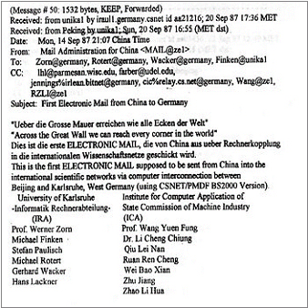
Nov 8 87 NSF approves China Email Stephen Wolff (NSF), Larry
Connection Landweber, Dave Farber
Mar 28.-30 88 CANET Inauguration and Minister Yang, Prof. Wang
and conference Dr. C.C.Li
`88 ff Propagation of CANET/Operation Prof. Wang/Dr. C.C.Li
Nov 90 Registration of CN Domain Appl. (Zorn) with techn contact Rotert,
admin Qian TianBai
‘91 ff Operation, Propagation of .CN Qian TianBai, Dr. Li, Prof. Wang
Rotert, Nipper
Mar 1 93 Visit W. Zorn TS- Handover and Strategic Planning
Apr 1 93 Plan to migrate to full internet Leased Line Proposal to SNI (W Zorn)
Services
Jun 16 93 Stop of further Activities Denial by SNI (MoB H.- D. Wendorff)
Until May 94 Operating Primary DNS CNNIC takes over DNS after direct US
In Karlsruhe link
http://www-fgks.hpi.uni-potsdam.de/src/pubzorn/How_China/ChinaConnection.pdf
--------------------------------------------------------------------A

Brief History of the Internet in Korea and Asia

Kilnam Chon, chon@cosmos.kaist.ac.kr
KAIST, Daejeon 305-701 South Korea

ABSTRACT

The TCP/IP network in South Korea started on May 15, 1982, one of the earliest Internet deployments in the world. The initial TCP/IP network, called SDN (System Development Network), consisted of two nodes with 1200 bps bandwidth. In January 1983, a third computer at KAIST (Korea Advanced Institute of Science and Technology) was connected to the SDN, which resulted in a system that could be described as a network of computers.

SDN served the research and education community with primary focus on network research, and had international links with UUCP initially. The international links cover several countries. From 1983, SDN was connected to various sites in Asia in addition to North America (hplabs and seismo in USA, CDNNET in Canada), and Europe (mcvax in the Netherlands). The network linking Asian countries was called AsiaNet, and included Australia, Indonesia, Japan, Korea, and Singapore.
In parallel to TCP/IP development, communications on personal computers using bulletin boards and others also proliferated. These two network developments along with the availability of WWW made explosive Internet growth in 1990s. Online communication using the PC communications operated as a separate service independent from the Internet until 1995 when regular PC network users were able to connect to the Internet using commercial networks. The most notable significance of the PC communications is that it contributed to the development of the concept of online communities. These developments resulted in South Korea being the leading broadband country with various applications used widely by the population. In 2005 the number of home users with broadband Internet access exceeded 12 million, which covers over 80% of the households in Korea.

It was in the early 1990s that individuals of the general public were able to express their diverse political and social opinions through the Internet. Various people and groups started to set up websites.
The Red Devils support club for the national soccer team played a very active role mobilizing massive cheering crowds in the 2002 World Cup Games.

When two middle school girls were killed by a U.S. armored tank in June 2002, on-the-street candle light vigils by netizens and online memorials spread throughout the country. In addition, during the December 2002 presidential election, there were many active online and offline campaigns organized and played out by many netizen groups such as People Who Love No Moo Hyun(Nosamo). These netizen groups did not spring up suddenly with the introduction of the Internet. Rather, they are extensions of online communities that were formed through the PC communications in the early 1990s, using the Internet as their newer communication medium.

The Internet is becoming the social infrastructure in Korea lately with many aspects of daily life done through the Internet including social and political activities. Convergence of the Internet with telecommunications and broadcasting is taking place now.

Paper: http://www.columbia.edu/~hauben/netizens/tunis-ppf/Kchon.doc
Slides: http://www.columbia.edu/~hauben/netizens/tunis-ppf/Kchon.ppt
-----------------------------------------------------------------------
Appendix 1: SDN Network Configuration (as of May 1985)
-
- 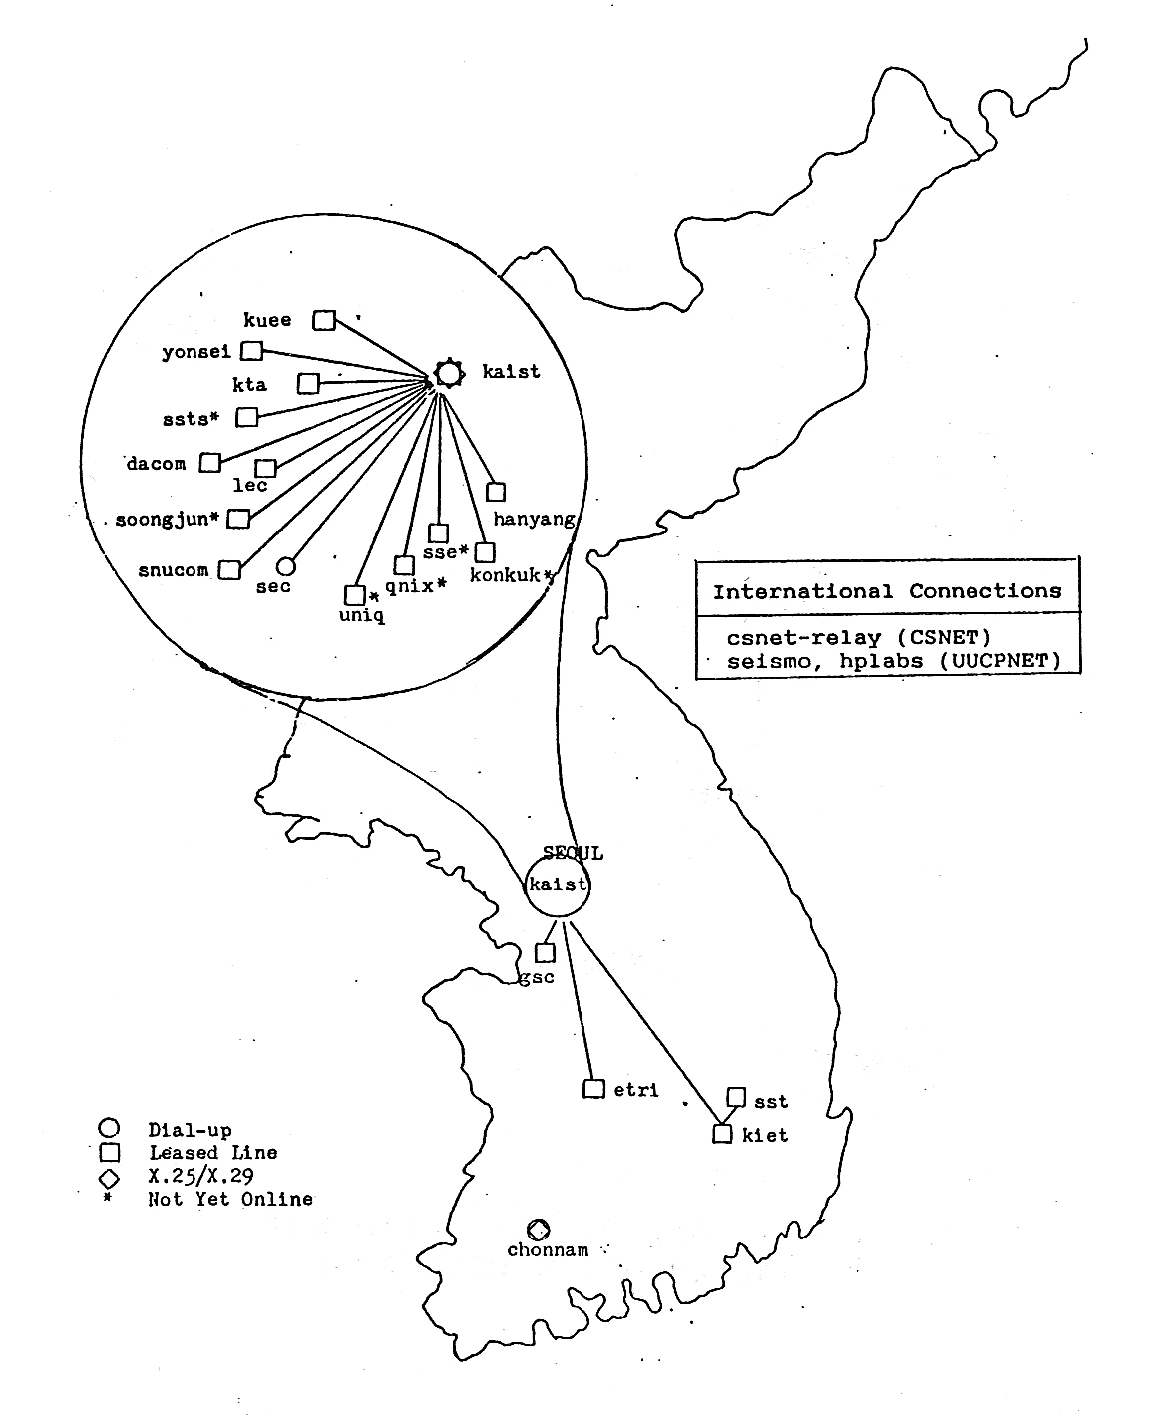

Appendix 2: AsiaNet – UUCP and USENET (source: PCCS, Oct 1985)
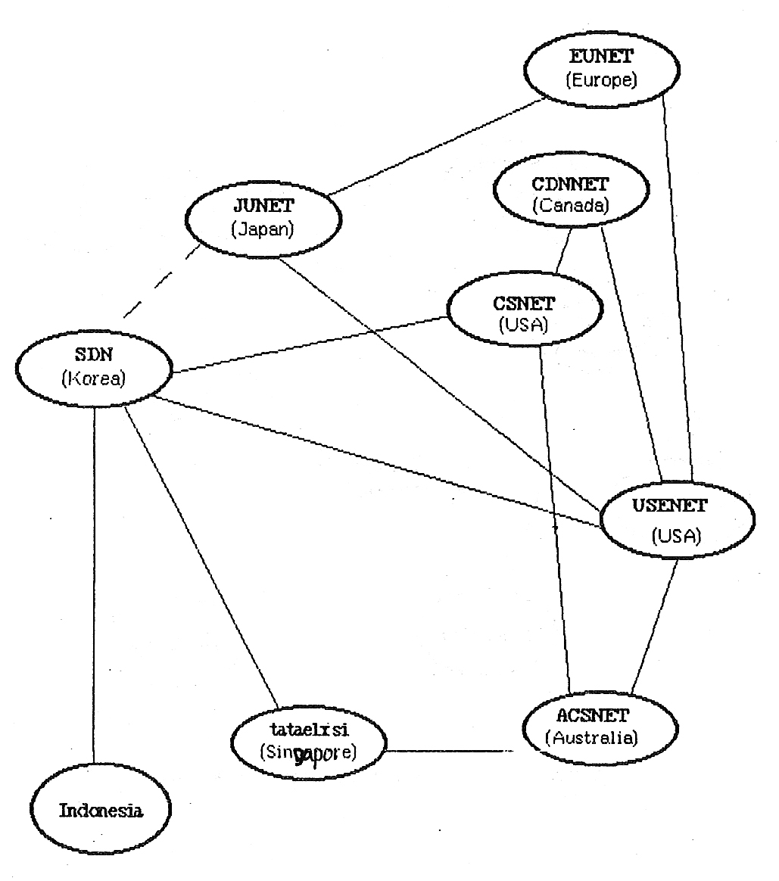
--------------------------------------------------------------------------------------------------

Netizens and Protecting the Public Interest in the Development and
Management of the Internet: An Economist's Perspective

Anders Ekeland, anders.ekeland@nifustep.no
Senior Researcher, NIFU STEP, Norway www.nifustep.no

ABSTRACT

The paper discusses various aspects of Internet governance with focus on the role that "economic theory" plays in this discussion. The fundamental question is of course what is the most important aspect of the Internet and in our opinion that is the free exchange of information and opinions. This is a common good and a public good. The commercial use of the Internet is of secondary importance from an Internet governance point of view. This is not the dominant point of view among economists. But there is no such thing as "economic theory" or one and only one way that economists view the Internet. There are neo-classical-, evolutionary-, institutional, post-keynesian theories; just to mention a few. Each of them is a broad church containing important different currents, which again contain the individual points of view. None of these theories, and in particular the policies they recommend, are neutral, objective, purely scientific. No social-science theory can be value-free. The paper takes as its starting point the policy recommendations made from "main-stream" economists regarding Internet governance. I define "main-stream" as economic theory that uses perfect competition as a static equilibrium as its benchmark for the optimal, "first best" state of markets. In equilibrium, the reference state everything is taken as given, "initial endowments", prices, technology -- and there is no role for government/institutions in the basic model. The need for regulation stems from "market failure". The paper argues that main-stream economics is too narrow in its analysis of Internet governance. First of all, it does not discuss the justice, the legitimacy of the "initial endowments", the initial distribution of power and/or property rights. There was international research cooperation from the beginning, but today the ultimate control over root servers and the DNS is with the US government.

The economists writing on Internet governance do not treat this question; it is taken as given and left to the lawyers. The law specialists have been mostly concerned with the controversial status of ICANN as a private institution making public policy. Secondly when it comes to the actual governance of the Internet, the DNS system, trademark issues etc. the main-stream economists believe in using markets. This raises several important questions. Not the least the fact that markets take into account money -- what about those who have legitimate needs not backed by money.

But even on the condition that we shall leave certain parts of Internet governance to markets, do markets actually work roughly as the model of perfect markets predict? If not -- how do we regulate the role of markets -- and the markets themselves in order to serve the public interest? Is the Internet a natural monopoly or should "we" encourage more competition among different "Internets", different DNS systems? What is the dynamic of such competition -- and who will it benefit?

Paper: http://www.columbia.edu/~hauben/netizens/tunis-ppf/AEkeland.doc
Slides: http://www.columbia.edu/~hauben/netizens/tunis-ppf/AEkeland.ppt

What is the role of “economic theory” in the discussion
about Internet development and governance?
There is not “economic theory” in singular. There are different paradigms in economics, different schools of thought inside each paradigm,
There are “main-stream” neo-classical theory, but also evolutionary, post-keynesian, Marxian theories, radical institutionalist theories.
But the neo-classical is special in its theoretical foundations, it is static, ahistoric, has very special theory of human rationality - this is the fundamental reason why “economics” and “economists” are in perpetual conflict with the other social sciences - if they have not succeeded in imposing the Gary Becker world view on the topic (crime, suicide, marriage).
The fact that one paradigm, the neo-classical theory, poses as the “economic theory” is in itself a phenomenon that needs critical analysis.
Since neo-classical theory is so extremely dominant - has a profound influence on policy formulation - including Internet governance we need to understand it, need to develop a theoretical and empirical critique.
Most people, including most economists do not realize the extreme static nature of this theory. They think that it is the result of a process where prices change - firms compete - and then equilibrium is reached. That is not case.
When there is “asymmetric information” - no reason why government, the research community should not know better than “Markets” - which of course has happened and happens all the time. Internet is of course a prime example of that.
By habit neo-classical theory takes the “initial endowments”, the is the distribution of wealth as given. “We study efficiency, politicians handle distribution” - this is only possible in complete static framework. Important for the self-image of “objectivity”, of “rigorousness” in contrast to other social science disciplines.
The Clinton - Gore privatization of the Internet: In July 1997 Clinton directed the Secretary of Commerce to privatize the Domain Name System. The Federal Regulation became know as the “Green Paper”.
There should be democratic, representative control over the Internet. Not by one government, especially not by a private, US institution, that lacks legitimacy, representative electoral procedures and open procedures.
The Internet was shaped by a two social groups - the researchers and the first, enthusiastic and competent users. They are fortunately still with us.
The question of “by whom” cannot be seen in isolation from “for whom” and “for what purpose”.
The UN, the ITU, ICANN - all have their “imperfections”. Some governments are not representative of their inhabitants at all. The basic answer to these imperfections is to strengthen the Internet-based discussion, consciously empower the participants in structurally unfavorable positions.
Neither “Markets” nor “Bureaucracy” is the solution.

Summary
There are several economic theories - neo-classical is clearly the most ideological of them. Weak scientific foundation, very strong policy, normative conclusions
Markets work, we must make them work for our purposes - a dynamic, realistic understanding of markets is crucial. The fundamental law of markets is: competition creates monopoly, only innovation counteracts that tendency.

One must grasp the fundamental contradiction between a democratic system:
one man one vote
versus
one dollar one vote

Only democratic system can decide on the development of society - including the Internet.
A fundamental criterion for a real economic theory is that it is democratic, i.e. the society is primary in the theory and markets are secondary.
-----------------------------------------------------------------------------------------------

