The China-Germany Email Connection1984-1994
by Jay Hauben
jrh@ais.org

In October 2004, Ronda and I met Werner Zorn in Berlin Germany. We had heard that Professor Zorn and Karlsruhe University were involved with the first email connectivity between the People's Republic of China and a foreign country. We were excited to meet Professor Zorn who turned out to be warm and wonderful. He had for us a pack of articles and papers documenting the early history of computer networking in China and between China and especially Germany. His story was very informative for anyone piecing together the international origin and history of the Internet. I want to tell the story Professor Zorn shared with us.

In the early 1980s the World Bank which extends credit and investments to developing countries, supported the import of foreign computers for use in 17 universities in China. Export of computers from the US to China was forbidden by the US government. But the German government had no such embargo. So the World Bank Chinese University Development Project II used some of the allotted $145 million for the import into China of 19 Siemens BS2000 mainframe computers manufactured in Germany.

Professor Zorn had experience with Siemens computers in his work as Professor of Computer Science at Karlsruhe University, a major institute for education and research in western Germany. His specialty was performance analysis and computer networks. Professor Zorn had been involved with the first German email connection with the US Computer Science Network (CSNET) in July 1984. Also, he began a warm relation with Professor Yunfeng Wang, Senior Advisor of the Chinese Institute of Computer Applications (ICA) in Beijing while organizing the First Chinese Siemens Computer User Conference (CASCO – Symposium ‘83) in Sept 1983 in Beijing.

The preparatory work for the China-Germany email connection had begun in late 1984, a few months after the Germany-US CSNET connectivity had been established. The Siemens BS2000 was to be the computer at ICA available for use for the email connection. It was hoped that the China-Germany email connection would be a step toward connecting China one day with the growing CSNET which used the CSNET/PMDF transport protocols. In Karlsruhe, it was decided to attempt to implement the CSNET/PMDF on a Siemens BS2000 there. Professor Zorn undertook this task together with his students from scratch, but only as a background job in addition to other tasks. Including the lower levels, it took at least two years to complete. The work was financially supported after November 1985 by the prime minister of the West German state of Baden-Wuerttemberg, Lothar Spaeth.

CSNET email traffic to and from Germany was routed using the X.25 lower level protocols. The X.25 protocols were the result of an effort to create a universal and global packet-switched network on what was then the bit-error prone analog telephone system. Much of the X.25 system is a description of the rigorous error correction needed to achieve this. In 1985, there was no physical path to carry X.25 email between China and Germany. To have such a path, telephone lines with switches that could route X.25 email traffic were needed. China had begun to develop a network of such switches for internal X.25. So had Germany. X.25 email traffic could be transported within China and within Germany. But there was no X.25 link between them. With the help of PKTELCOM in Beijing, the Karlsruhe team made contact with the Italian carrier Italcable which had some leased lines between China and Italy. Italcable agreed to open its switches to route the anticipated X.25 email traffic between China and Germany. It was able to open its switches on Aug. 26 1986. From that day on, reliable remote computer to computer dialogue was available between Karlsruhe and ICA through PKTELCOM. This channel made possible the communication necessary during the implementation phase of the China-Germany email connection a year later in 1987. Also, when the computer scientists at ICA and Karlsruhe could implement the X.25 and CSNET/PMDF protocols on the Siemens BS2000 computer at ICA in Beijing, the China-Germany connection would have an X.25 route through Italy.

In late summer 1987, Professor Zorn was in Beijing for the third CASCO conference where he gave the keynote address on “Computer Networks”. But also he was there to work with the staff of the ICA to set up the first email connectivity between China and Germany. His team at Karlsruhe had succeeded in getting the CSNET/PMDF protocols to work on their Siemens BS2000 computer. Over an 11 day period, September 4 to 14, 1987, assisted by the staff of ICA, Professor Zorn with his team implemented within the operating system of the ICA Siemens 7760/BS2000 computer the necessary protocols to make possible email connectivity with Karlsruhe. For the lower three OSI layers, X.25 was used. As the transport protocol of layer 4, the CSNET/PMDF protocols were used. For the higher layers, application oriented protocols for the email service of CSNET were used. On September 14, 1987, Professor Zorn and the ICA staff achieved the breakthrough they needed, host-to-host connectivity with Karlsruhe. Professor Zorn was able then to leave half of his team in Beijing to finish the job.

Before he left, they composed an email message with the subject line, "First Electronic Mail from China to Germany". The message began in German and English, "Across the Great Wall we can reach every corner in the world." The message, with a cc: to his home mailbox zorn@ira.uka.de, was signed by Professor Zorn for the University of Karlsruhe Computer Science Department (Informatik Rechnerabteilung) and Professor Yunfeng Wang for the ICA. Eleven coworkers are listed, Michael Finken, Stefan Paulisch, Michael Rotert, Gerhard Wacker and Hans Lackner on the Karlsruhe side and Dr. Li Cheng Chiung, Qiu Lei Nan, Ruen Ren Cheng, Wei Bao Xian, Zhu Jiang and Zhao Li Hua on the ICA side, suggesting the complexity of the task. Professor Zorn mentioned Dr. Li Cheng Chiung in particular as playing an important role as the Director of the ICA Computing Center. Successful connectivity was achieved in a few more days. On September 20, 1987, the first email message, the one composed on September 14, could actually be sent to the VAX 11/750 computer at Karlsruhe.

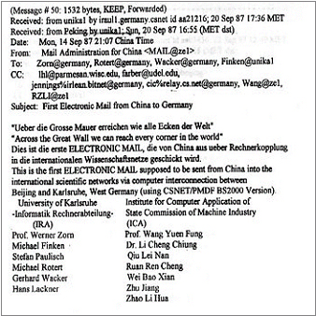
The First Email Message to Leave China (http://www.internetdigital.org/image/firstemail.jpg)

The first step was taken for the people of China to begin online communication with people all over the world.

The email connectivity between China and Germany was only the necessary technical precondition for an email service. What was missing was the official approval of the US authorities who funded CSNET. Immediately after the technical connectivity was achieved, Professor Zorn worked with Professor Wang to win acceptance from the US National Science Foundation (NSF) for worldwide email traffic to and from China. With the help of Professor Lawrence H. Landweber, the Chairman of the CSNET project, acceptance by the NSF was achieved less than two months later. On November 8, 1987, in a letter to the executive committees of CSNET and BITNET, Stephen Wolff, Director of the NSF Division of Networking and Communications Research and Infrastructure welcomed the CSNET email connectivity with China.

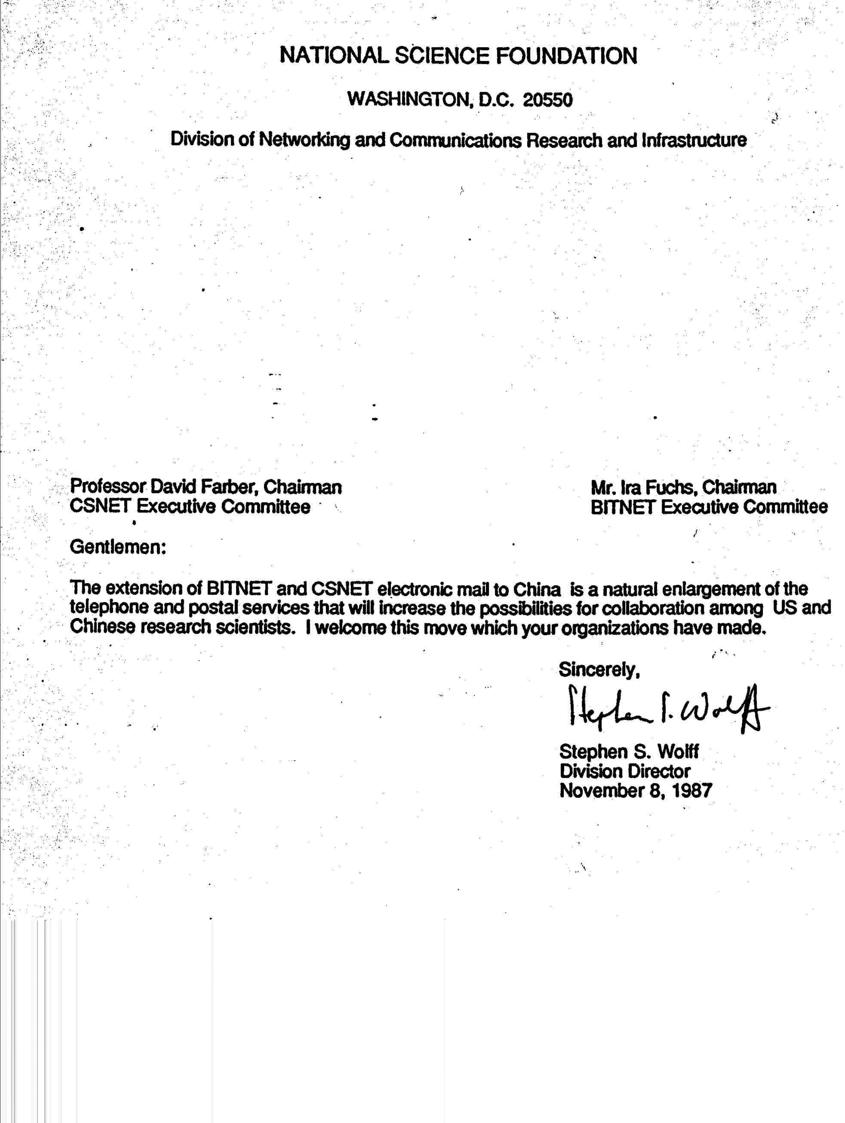
Letter from Stephen Wolff, November8, 1987

This letter was the official political approval, of what technically was already implemented. World wide reachability was already achieved and operational on Sept. 20. But it was still not approved by the NSF, which was the umbrella institution for all networking within the US and also abroad at that time. Without Steven Wolff's letter, the connection would have been vulnerable to a cutoff if the NSF decided to deny forwarding of emails messages to and from ICA. Professor Zorn counts November 8 as the time China became officially connected with the rest of the world via the CSNET email system. Email received from China at Karlsruhe could be relayed from there to whichever host worldwide it was addressed. And the reverse, any host worldwide could send mail to ICA in Beijing and it could be relayed from there to users of the China Academic Net (CANET) throughout China as well as to remote dialogue users in other Chinese institutions outside CANET. The international computer science community and Chinese students abroad who learned of this connectivity answered with their warm congratulations.

Still these were small steps. Even with the support of the Chinese State Science and Technology Commission (SSTC), hardly any Chinese institution and no individual scientist could afford to send or receive email messages to or from abroad. There were charges for every email message sent or received and these were prohibitive. Professor Zorn estimated that longer email message could cost a professor the equivalent of a whole month's salary. The charge was mostly for telephone and satellite tariffs, typically $2000 to $5,000 per month paid by each side. Email usage was thus severely restricted.

But for the five years during which expensive email connectivity was the only network connectivity that could reach the rest of the world, China prepared itself to truly join the Internet.

In October 1990, the ICA registered the .CN country code domain name for China, again with crucial help from Professor Zorn and Karlsruhe University. Qian Tianbai, a Senior Engineer at ICA was appointed as the Administrative Contact for .CN on the Chinese side. During the following four years, Professor Zorn's Center in Karlsruhe ran the primary domain name server for .CN on their iraun1.ira.uka.de VAX 3500. From January 1991, email service was available in and to and from China with China's own domain name.

With encouragement from the Chinese government, knowledge and understanding of the Internet was spreading in China especially in the scientific and computer communities. The Institute for High Energy Physics (IHEP) belonging to the Chinese Academy of Science opened an email connection in 1989 with its partner in the US, the Stanford Linear Accelerator Center (SLAC) in California. Message Handling Systems (MHS) were set up in 1990 between the German Research Network (DFN) and the Chinese Research Network (CRN) and between the Beijing Tsinghua University Network (TUNET) and its partner in Canada at the University of British Columbia (UBC). Also, CHINAPAC an X.25 public telephone infrastructure was developed and used for email exchanged within China.

The email-only phase of connectivity of China and the rest of the world through Karlsruhe came to an end when IHEP worked together with SLAC to take the next big step in connectivity between the people of China and the people of the world. On May 17, 1994, IHEP and SLAC established a full TCP/IP connection between China and the US. That connectivity opened the Internet to China and China to the Internet.

Some of the story of the Internet in China after 1994 is told online at a number of web sites. 2004 was the Tenth Anniversary of TCP/IP connectivity. In early 2005, it was estimated that there were at least 100 million Internet users in China and Internet use was growing at perhaps 30% a year. There was a dynamic netizens movement holding the Chinese government and Party up to high standards. It can only make computer network pioneers like Yunfeng Wang, Werner Zorn, and Li Cheng Chiung proud of what they did and celebrated by any of us who respect the progress the Internet represents for human society.
---
The author wants to thank Werner Zorn in Germany, without whom many of the details and this story would have remained unknown. In many ways he is a coauthor. I thank him and Dr. Li Cheng Chiung in China for encouragement to tell this story with correct details. They are keeping the pioneer spirit alive.

For over 30 years Werner Zorn was affiliated with Karlsruhe University in Karlsruhe, Germany. Today he is a professor of Communications Systems at the Hasso-Plattner Institute (www.hpi.uni-potsdam.de) at the University of Potsdam.
? The papers included, “Wie China mit den internationalen Rechnernetzen verbunden wurde” In: PIK – Praxis der Informationsverarbeitung und Kommunikation 11 (1988), No. 1 pages 22-29, and “Die Entwicklun des Internet in China” written with Qian Tianbai, June , 1998. See also, http://www.cnnic.net.cn/html/Dir/2004/06/21/2349.html
Werner Zorn was the Administrative Liaison at Karlsruhe University which joined CSNET in July 1984 as one of two gateways between CSNET and European research networks. (see CSNET NEWS Summer 1984, No 5, pages 5 and 6)
CASCO- Chinesische Anwender von Siemens Computern.
? http://en.wikipedia.org/wiki/X.25
When Professor Zorn read the above article he wrote to me about Professor Landweber. "Without his everlasting support from 1984 and after, the whole work would not have been possible." Professor Zorn also wrote that the email connection project was strongly supported by many leading network people of the world. He named, besides professor Landweber and Stephen Wolff, Professor Wang in China and for example Dennis Jennings from the US and Daniel Karrenberg from the Netherlands who attended the first CANET conference in Beijing in March 1988 and Kilnam Chon from Korea who was active in networking in the Asia/Pacific Rim region. (email messages April 28 and May 18, 2005).
Qian Tianbai is often mistakenly given credit for the first email message from China to Germany. Dr. Li Cheng Chiung who was the director of the ICA from 1980 to 1990 writes that Qian Tianbai was a Senior Engineer at the ICA from 1980 to 1998 but that he was in the US studying at the CSTcompany for the whole of the year in 1987. He includes that Mr. Qian was a good engineer who did interesting work and joined the CANET project in 1990 (email messages to the author May 10, May 11, and May 17, 2005). Werner Zorn writes that his email contact with Qian Tianbai started not before 1990 (email message to the author May 3, 2005). It can be noted that in the first email message from China to Germany, Qian Tianbai does not appear among the 13 signatories. Sadly, Qian Tianbai died of a sudden heart attack on May 8, 1998.
? http://www.nsrc.org/db/lookup/operation=lookup-report/ID=890202373777:497422478/fromPage=CN
? See for example, http://www.internetdigital.org/p222shinianqingdian.htm http://www.pcworld.idg.com.au/index.php/id;854351844;fp;2;fpid;1 http://lass.calumet.purdue.edu/cca/gmj/SubmittedDocuments/archivedpapers/Fall2003/pdf_files/Internet%20and%20democracy(xiguang).pdf

