

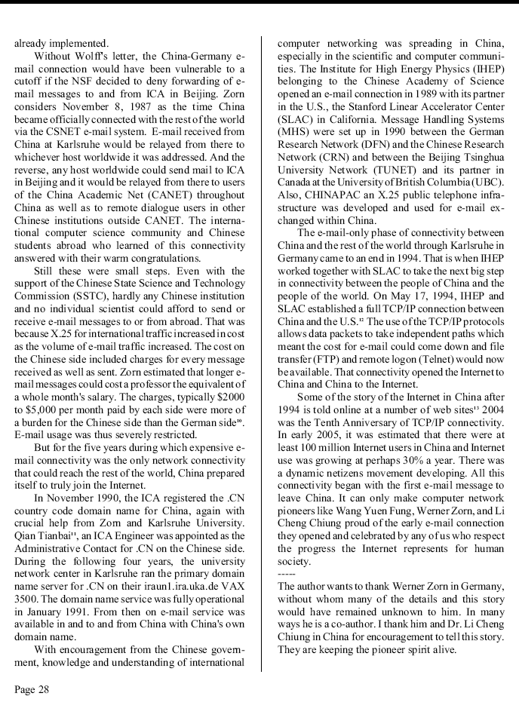
----------------------------------------------------------------------
Reprinted from the Amateur Computerist Vol 13 No 1, Spring 2005. The
whole issue or a subscription is available for free via email. Send
a request to jrh@ais.org or see http://www.ais.org/~jrh/acn/

